**Praktikum 9 – Data Analitik**

**METODE DEKOMPOSISI DAN HOLT WINTER**

Analisis deret waktu (*time series*) dapat menggunakan berbagai macam model yang populer seperti metode dekomposisi*,* model winter's, regresi deret waktu, dan model ARIMA. Model peramalan tersebut dapat digunakan untuk peramalan data yang mengandung pola musiman dan/atau tren. Data yang digunakan dalam praktikum berupa data sekunder deret waktu volume pasokan (ton) dan harga beras (rupiah) ke Pasar Induk Beras Cipinang (PIBC) per bulan. Karakteristik pasokan beras berikut peramalannya dari berbagai wilayah tersebut kiranya perlu dipahami oleh pengelola PIBC yang bertugas antara lain melakukan pemantauan data pasokan, distribusi dan harga beras. Data tersebut diolah menggunakan dua metode yaitu metode *Holt-Winter* serta metode Dekomposisi. Metode Winter menggunakan *seasonal length* sebesar 12 serta dua tipe metode yaitu *multiplicative* dan *additive*. Metode peramalan ini dipilih karena termasuk metode yang sesuai untuk kasus peramalan dengan pola *trend* dan *seasonal* (Fogarty *et al*, 1991; Minitab, 2000).

**Creating a time series**

|  |
| --- |
| # save a numeric vector containing 72 monthly observations # from Jan 2009 to Dec 2014 as a time series object myts <- ts(myvector, start=c(2009, 1), end=c(2014, 12), frequency=12)   # subset the time series (June 2014 to December 2014) myts2 <- window(myts, start=c(2014, 6), end=c(2014, 12))   # plot series plot(myts) |

<https://www.statmethods.net/advstats/timeseries.html>

**FORECASTING**

**# triple exponential - models level, trend, and seasonal components**

|  |
| --- |
| > library(RMySQL)  > con = dbConnect(MySQL(), user = 'root', password = '', dbname =  + 'db_da', host = 'localhost')  > myQuery <- "select * from ricesupply;"  > ricesupply_stev <- dbGetQuery(con, myQuery)  > View(ricesupply_stev) |

|  |
| --- |
| > supply_stev <- ts(ricesupply_stev$Karawang, start = c(2011, 1), frequency = 12)  > plot(supply_stev)    > library(forecast)  > fit <- HoltWinters(supply_stev)  > accuracy (f1)  ME RMSE MAE MPE MAPE MASE ACF1  Training set -586.4917 4039.34 3129.785 -6.294659 21.21714 0.5946464 0.04091717  > f1 <- forecast(fit,h=12)  > print(f1)  Point Forecast Lo 80 Hi 80 Lo 95 Hi 95  Jan 2016 14279.50 10152.926 18406.08 7968.448 20590.56  Feb 2016 10403.28 6141.533 14665.03 3885.500 16921.06  Mar 2016 17532.97 13114.363 21951.58 10775.292 24290.66  Apr 2016 26549.85 21952.640 31147.06 19519.024 33580.68  May 2016 27862.61 23065.315 32659.90 20525.784 35199.43  Jun 2016 26716.46 21698.102 31734.82 19041.545 34391.37  Jul 2016 18391.20 13131.455 23650.95 10347.115 26435.29  Aug 2016 25811.05 20290.372 31331.72 17367.903 34254.19  Sep 2016 23967.52 18167.216 29767.83 15096.719 32838.32  Oct 2016 26638.78 20541.006 32736.55 17313.040 35964.52  Nov 2016 31206.57 24794.346 37618.79 21399.922 41013.21  Dec 2016 25722.63 18979.818 32465.45 15410.388 36034.88  > forecast(fit,12)  Point Forecast Lo 80 Hi 80 Lo 95 Hi 95  Jan 2016 14279.50 10152.926 18406.08 7968.448 20590.56  Feb 2016 10403.28 6141.533 14665.03 3885.500 16921.06  Mar 2016 17532.97 13114.363 21951.58 10775.292 24290.66  Apr 2016 26549.85 21952.640 31147.06 19519.024 33580.68  May 2016 27862.61 23065.315 32659.90 20525.784 35199.43  Jun 2016 26716.46 21698.102 31734.82 19041.545 34391.37  Jul 2016 18391.20 13131.455 23650.95 10347.115 26435.29  Aug 2016 25811.05 20290.372 31331.72 17367.903 34254.19  Sep 2016 23967.52 18167.216 29767.83 15096.719 32838.32  Oct 2016 26638.78 20541.006 32736.55 17313.040 35964.52  Nov 2016 31206.57 24794.346 37618.79 21399.922 41013.21  Dec 2016 25722.63 18979.818 32465.45 15410.388 36034.88 |

**# Seasonal decomposition**

|  |
| --- |
| > ricets <- ts(ricesupply_stev$Cirebon, frequency=12, start=c(2011,1))  > ricets  Jan Feb Mar Apr May Jun Jul Aug Sep Oct Nov Dec  2011 14991 18099 26227 26939 27555 21858 22739 20520 26754 24516 27071 21156  2012 14485 12567 17589 23187 25573 18805 19139 15642 22940 21524 22177 15986  2013 14606 10383 17416 23242 22237 19262 18092 17449 23699 25200 22962 17723  2014 16536 10978 12354 19812 20924 17611 13630 25190 24325 24643 19430 17335  2015 12163 6170 15342 24457 25672 27051 16846 25588 21895 24915 25046 23400  > plot.ts(ricets)    > fit <- stl(ricets_stev,s.window="periodic")  > plot(fit)    > fit <- forecast(ricets_stev)  > accuracy(fit)  ME RMSE MAE MPE MAPE MASE ACF1  Training set -28.52988 2715.479 2068.561 -2.025352 11.01005 0.6836617 0.01990205  > ricedec <- decompose(ricets_stev)  > ricedec$seasonal  Jan Feb Mar Apr May Jun Jul  2011 -5025.1059 -9439.5122 -3790.9392 3254.7691 4198.7066 1277.1753 -1621.4913  2012 -5025.1059 -9439.5122 -3790.9392 3254.7691 4198.7066 1277.1753 -1621.4913  2013 -5025.1059 -9439.5122 -3790.9392 3254.7691 4198.7066 1277.1753 -1621.4913  2014 -5025.1059 -9439.5122 -3790.9392 3254.7691 4198.7066 1277.1753 -1621.4913  2015 -5025.1059 -9439.5122 -3790.9392 3254.7691 4198.7066 1277.1753 -1621.4913  Aug Sep Oct Nov Dec  2011 -167.5226 4799.3733 4479.8628 3464.5816 -1429.8976  2012 -167.5226 4799.3733 4479.8628 3464.5816 -1429.8976  2013 -167.5226 4799.3733 4479.8628 3464.5816 -1429.8976  2014 -167.5226 4799.3733 4479.8628 3464.5816 -1429.8976  2015 -167.5226 4799.3733 4479.8628 3464.5816 -1429.8976  > plot(ricedec)    > View(ricets)    > library(xlsx)  > write.xlsx(ricets, "D:/semester 6/Data Analitik/Praktikum/prak9/Cirebon.xlsx") |

**Tugas praktikum**

Gunakan dua matriks data (pasokan dan harga beras) serta ambil **data dari satu kota** (data pasokan / **ricesupply**) dan **satu jenis beras** (data harga / **hargaberas**). Lakukan perbandingan nilai akurasi dari kedua jenis metode peramalan untuk data musiman (seasonal). Manakah yang errornya lebih kecil. Setiap praktikan tidak boleh sama jenis beras atau kotanya.

**Misal:**

Data ricesupply : mencoba kota bandung

Data hargaberas: mencoba jenis beras Muncul II

> library(RMySQL)

> con = dbConnect(MySQL(), user = 'root', password = '', dbname ='db_da', host = 'localhost')

> myQuery <- "select * from ricesupply;"

> ricesupply_stev <- dbGetQuery(con, myQuery)

> View(ricesupply_stev)

> supply_tugas <- ts(ricesupply_stev$Jateng, start = c(2011, 1), frequency = 12)

> plot(supply_tugas)

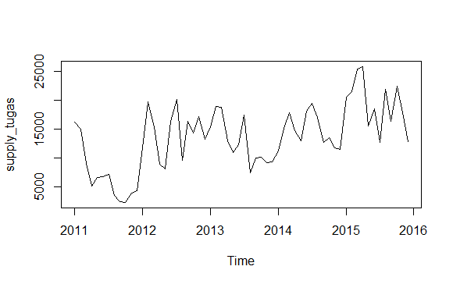

> library(forecast)

**HotlWinters**

> fit <- HoltWinters(supply_tugas)

> f1 <- forecast(fit,h=12)

> accuracy (f1)

ME RMSE MAE MPE MAPE MASE ACF1

Training set -586.4917 4039.34 3129.785 -6.294659 21.21714 0.5946464 0.04091717

> print(f1)

Point Forecast Lo 80 Hi 80 Lo 95 Hi 95

Jan 2016 23189.55 18013.59 28365.52 15273.597 31105.51

Feb 2016 24917.21 19318.07 30516.35 16354.067 33480.36

Mar 2016 28760.62 22754.64 34766.60 19575.265 37945.97

Apr 2016 27224.08 20824.26 33623.90 17436.404 37011.76

May 2016 18935.91 12152.78 25719.04 8562.004 29309.81

Jun 2016 23533.82 16376.02 30691.63 12586.903 34480.75

Jul 2016 21957.35 14432.03 29482.67 10448.363 33466.33

Aug 2016 27964.56 20077.70 35851.41 15902.655 40026.46

Sep 2016 21830.43 13587.07 30073.80 9223.299 34437.57

Oct 2016 25602.40 17006.76 34198.04 12456.507 38748.29

Nov 2016 21201.43 12257.10 30145.77 7522.249 34880.61

Dec 2016 18446.62 9156.61 27736.63 4238.775 32654.47

> forecast(fit,12)

Point Forecast Lo 80 Hi 80 Lo 95 Hi 95

Jan 2016 23189.55 18013.59 28365.52 15273.597 31105.51

Feb 2016 24917.21 19318.07 30516.35 16354.067 33480.36

Mar 2016 28760.62 22754.64 34766.60 19575.265 37945.97

Apr 2016 27224.08 20824.26 33623.90 17436.404 37011.76

May 2016 18935.91 12152.78 25719.04 8562.004 29309.81

Jun 2016 23533.82 16376.02 30691.63 12586.903 34480.75

Jul 2016 21957.35 14432.03 29482.67 10448.363 33466.33

Aug 2016 27964.56 20077.70 35851.41 15902.655 40026.46

Sep 2016 21830.43 13587.07 30073.80 9223.299 34437.57

Oct 2016 25602.40 17006.76 34198.04 12456.507 38748.29

Nov 2016 21201.43 12257.10 30145.77 7522.249 34880.61

Dec 2016 18446.62 9156.61 27736.63 4238.775 32654.47

**Decomposition**

> ricets_stev <- ts(ricesupply_stev$Jateng, frequency=12, start=c(2011,1))

> ricets_stev

Jan Feb Mar Apr May Jun Jul Aug Sep Oct Nov Dec

2011 16269 14965 9145 5152 6707 6753 7239 3572 2503 2412 3951 4399

2012 11844 19736 15400 8998 8103 16388 20176 9666 16401 14280 17120 13300

2013 15446 18959 18724 12929 11006 12283 17431 7513 9993 10146 9168 9342

2014 11291 15174 17868 14777 13020 18106 19482 16988 12742 13468 11798 11506

2015 20496 21505 25367 25753 15554 18573 12761 21833 16353 22455 17867 12839

> plot.ts(ricets_stev)

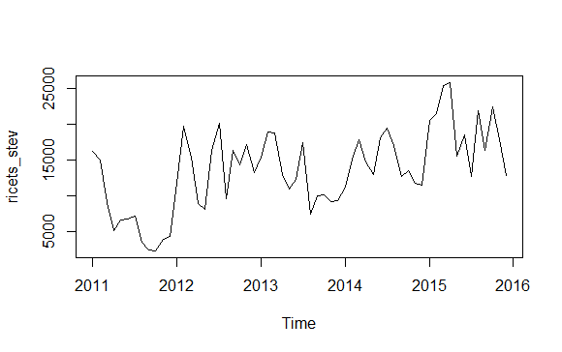

> fit <- stl(ricets_stev,s.window="period")

> plot(fit)

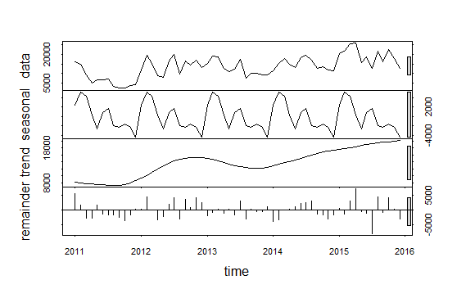

> fit <- forecast(ricets_stev)

> accuracy(fit)

ME RMSE MAE MPE MAPE MASE ACF1

Training set 9.523183 4384.984 3463.91 -9.258103 29.81001 0.6581288 0.08428807

> ricedec <- decompose(ricets_stev)

> ricedec$seasonal

Jan Feb Mar Apr May Jun Jul Aug

2011 1142.400 4968.911 5130.671 1052.119 -2995.121 1188.754 3890.661 -2868.746

2012 1142.400 4968.911 5130.671 1052.119 -2995.121 1188.754 3890.661 -2868.746

2013 1142.400 4968.911 5130.671 1052.119 -2995.121 1188.754 3890.661 -2868.746

2014 1142.400 4968.911 5130.671 1052.119 -2995.121 1188.754 3890.661 -2868.746

2015 1142.400 4968.911 5130.671 1052.119 -2995.121 1188.754 3890.661 -2868.746

Sep Oct Nov Dec

2011 -2130.850 -2847.673 -2721.673 -3809.454

2012 -2130.850 -2847.673 -2721.673 -3809.454

2013 -2130.850 -2847.673 -2721.673 -3809.454

2014 -2130.850 -2847.673 -2721.673 -3809.454

2015 -2130.850 -2847.673 -2721.673 -3809.454

> plot(ricedec)

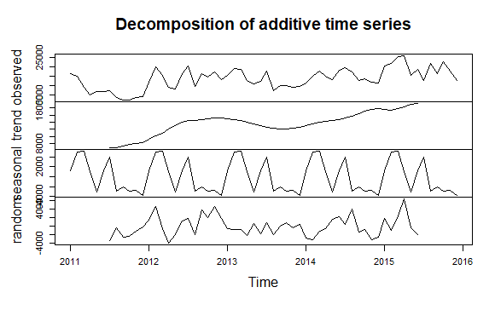

> write.xlsx(ricets_stev, "D:/semester 6/Data Analitik/Praktikum/prak9/Jateng.xlsx")



**KESIMPULAN :**

**HoltWInter akurasi :**

RMSE

4039.34

**Decomposition akurasi :**

RMSE

4384.984

Jadi metode yang lebih akurat adalah HoltWinter.

**Data Harga Beras**

> myQuery <- "select * from hargaberas;"

> hargaberas_stev <- dbGetQuery(con, myQuery)

There were 14 warnings (use warnings() to see them)

> hargaberas_tugas <- ts(hargaberas_stev$Saigon, start = c(2011, 1), frequency = 12)

> plot(hargaberas_tugas)

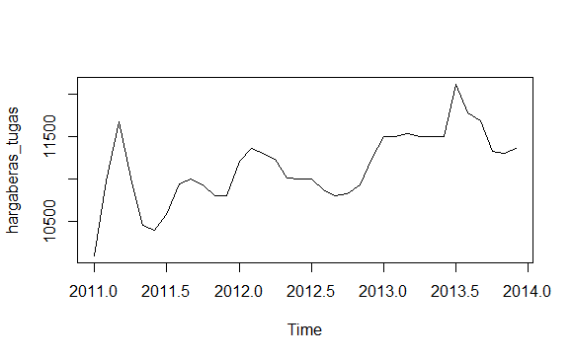

**Holtwinter**

> fit <- HoltWinters(hargaberas_tugas)

> f1 <- forecast(fit,h=12)

> accuracy (f1)

ME RMSE MAE MPE MAPE MASE ACF1

Training set 10.79992 257.418 178.1804 0.07778775 1.564177 0.4092392 0.1760123

> print(f1)

Point Forecast Lo 80 Hi 80 Lo 95 Hi 95

Jan 2014 11649.42 11312.72 11986.11 11134.49 12164.35

Feb 2014 11738.43 11331.19 12145.66 11115.61 12361.24

Mar 2014 11739.77 11272.52 12207.02 11025.17 12454.37

Apr 2014 11691.92 11171.53 12212.31 10896.05 12487.78

May 2014 11547.07 10978.48 12115.65 10677.49 12416.64

Jun 2014 11492.64 10879.64 12105.64 10555.14 12430.14

Jul 2014 11576.57 10922.16 12230.97 10575.74 12577.39

Aug 2014 11390.26 10696.91 12083.60 10329.88 12450.64

Sep 2014 11479.66 10749.45 12209.87 10362.90 12596.42

Oct 2014 11447.99 10682.69 12213.30 10277.56 12618.42

Nov 2014 11504.50 10705.64 12303.35 10282.75 12726.24

Dec 2014 11559.69 10728.63 12390.74 10288.70 12830.68

> forecast(fit,12)

Point Forecast Lo 80 Hi 80 Lo 95 Hi 95

Jan 2014 11649.42 11312.72 11986.11 11134.49 12164.35

Feb 2014 11738.43 11331.19 12145.66 11115.61 12361.24

Mar 2014 11739.77 11272.52 12207.02 11025.17 12454.37

Apr 2014 11691.92 11171.53 12212.31 10896.05 12487.78

May 2014 11547.07 10978.48 12115.65 10677.49 12416.64

Jun 2014 11492.64 10879.64 12105.64 10555.14 12430.14

Jul 2014 11576.57 10922.16 12230.97 10575.74 12577.39

Aug 2014 11390.26 10696.91 12083.60 10329.88 12450.64

Sep 2014 11479.66 10749.45 12209.87 10362.90 12596.42

Oct 2014 11447.99 10682.69 12213.30 10277.56 12618.42

Nov 2014 11504.50 10705.64 12303.35 10282.75 12726.24

Dec 2014 11559.69 10728.63 12390.74 10288.70 12830.68

**Decomposition**

> berasts_stev <- ts(hargaberas_stev$Saigon, frequency=12, start=c(2011,1))

> berasts_stev

Jan Feb Mar Apr May Jun Jul Aug Sep

2011 10100.00 10975.00 11677.42 11010.00 10451.61 10400.00 10583.33 10948.39 11000.00

2012 11209.68 11362.07 11300.00 11236.67 11012.90 11000.00 11000.00 10870.97 10800.00

2013 11500.00 11500.00 11532.26 11500.00 11500.00 11500.00 12113.55 11779.77 11684.17

Oct Nov Dec

2011 10935.48 10800.00 10800.00

2012 10822.58 10933.33 11245.16

2013 11323.39 11305.83 11356.25

> plot.ts(berasts_stev)

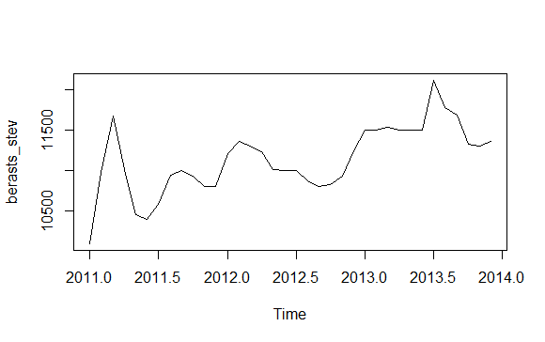

> fit <- stl(berasts_stev,s.window="period")

> plot(fit)

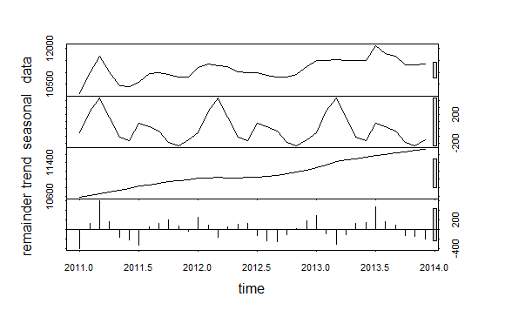

> fit <- forecast(berasts_stev)

> accuracy(fit)

ME RMSE MAE MPE MAPE MASE ACF1

Training set 15.2763 324.3719 214.4951 0.09445943 1.934448 0.4926456 0.01497095

> ricedec <- decompose(berasts_stev)

> ricedec$seasonal

Jan Feb Mar Apr May Jun Jul

2011 212.672572 239.668302 193.188810 123.058326 -7.442906 -36.021257 -163.693918

2012 212.672572 239.668302 193.188810 123.058326 -7.442906 -36.021257 -163.693918

2013 212.672572 239.668302 193.188810 123.058326 -7.442906 -36.021257 -163.693918

Aug Sep Oct Nov Dec

2011 -85.787329 -103.378056 -131.529935 -175.945262 -64.789346

2012 -85.787329 -103.378056 -131.529935 -175.945262 -64.789346

2013 -85.787329 -103.378056 -131.529935 -175.945262 -64.789346

> plot(ricedec)

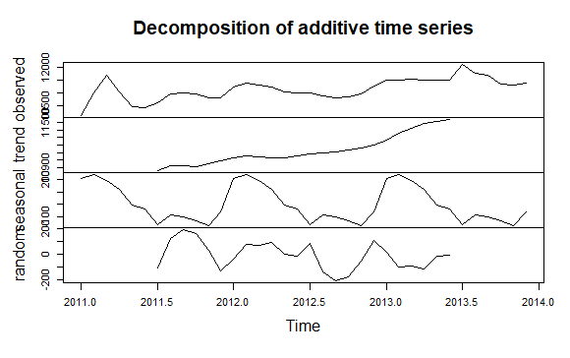

> View(berasts_stev)

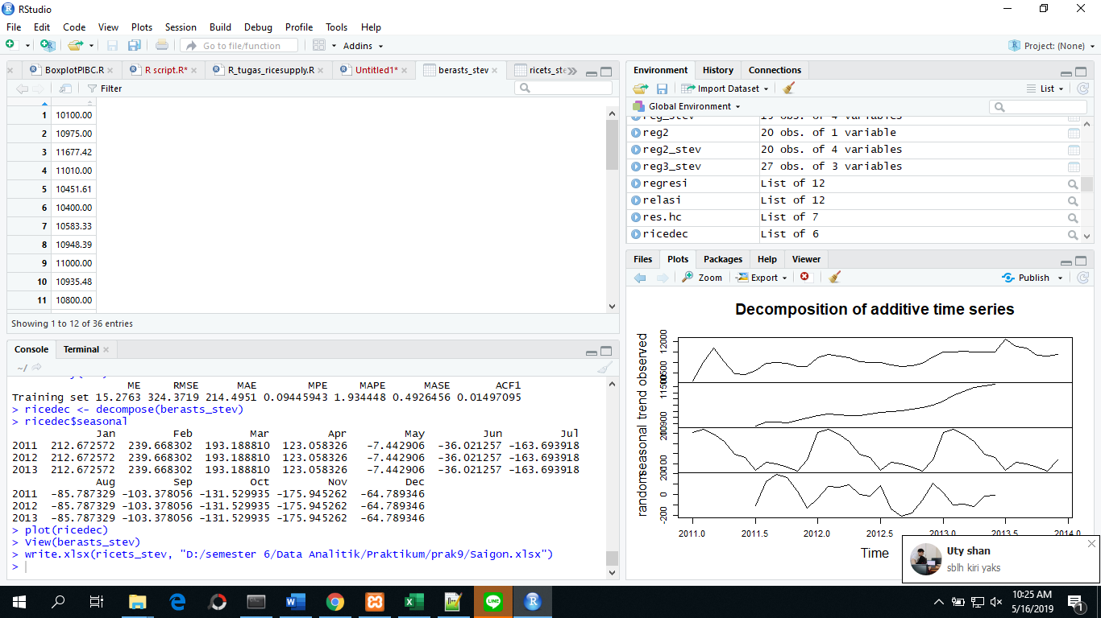

> write.xlsx(ricets_stev, "D:/semester 6/Data Analitik/Praktikum/prak9/Saigon.xlsx")

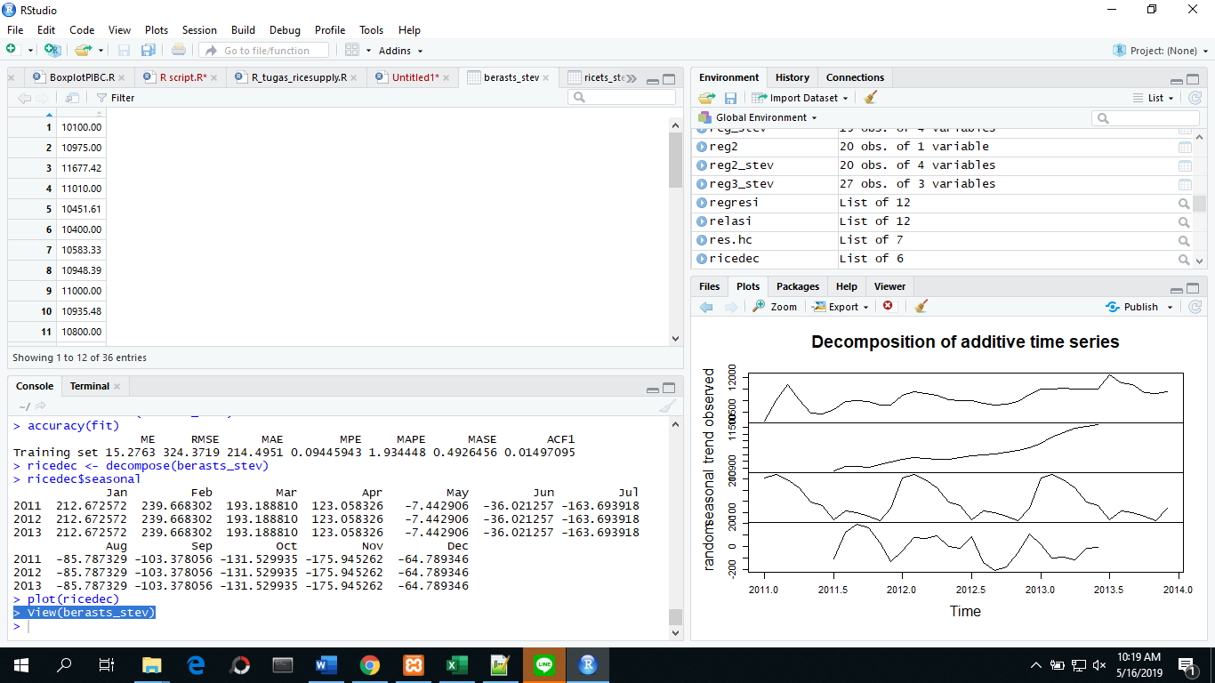

**KESIMPULAN :**

**HoltWInter akurasi :**

RMSE

257.418

**Decomposition akurasi :**

RMSE

324.3719

Jadi metode yang lebih akurat adalah HoltWinter.